txn-statement-analyzer: Skill Proposal
Oct 11, 2026 · @Dayesh Raval

Summary
txn-statement-analyzer turns a bank or credit-card statement CSV into a spending breakdown, recurring charges, unusual charges and monthly cash flow, where every number comes from a tested Python script, never from the model's own arithmetic. The agent runs scripts/analyze.py, reads its JSON, and writes the explanation with a source key beside each figure. It is skill 2 of the agent-skills roadmap and teaches the bundled-scripts pattern: deterministic code does the math, the LLM only narrates.

Business goals
The skill exists to give a trustworthy money summary in under a minute, with zero arithmetic errors. Targets are proposed and get confirmed on the sample data in step 3.
Goal | Metric | Target
Correct numbers | Figures in the narrative that differ from the script's JSON | 0
Traceable numbers | Figures in the narrative without a source key | 0
Catches problems | Planted recurring charges, anomalies and duplicates found in the sample | All
Low noise | False anomaly flags on the sample | 0
Runs anywhere | Installs needed beyond Python 3 | None
Private | Data sent off the machine | None
Secondary goal: a second public portfolio piece that shows tested tooling, not just prompts, and extends the fintech story (FinSentry, KORE anomaly detection).

What it is
An Agent Skills folder with a SKILL.md, a script the agent runs, editable rule files and a synthetic example.
Input: one statement CSV. v1 reads the generic layout Date, Description, Amount (negative = spend); column-mapping.md tells the agent how to adapt other banks' exports.
Output: monthly income, spend and net; spend by category; recurring charges; unusual charges; possible duplicates; a short narrative where every number carries a key such as [monthly.2026-08.spend].
skills/txn-statement-analyzer/
├── SKILL.md # procedure: find CSV, run script, narrate with keys
├── scripts/
│ ├── analyze.py # Python standard library only, prints JSON
│ └── test_analyze.py # self-check against the sample's known answers
├── references/
│ ├── categories.md # keyword to category rules (user-editable)
│ └── column-mapping.md # reading other banks' CSV layouts
└── examples/
├── sample-statement.csv # synthetic, 3 months, about 150 rows
└── sample-output.md # gold-standard narrative

How it works
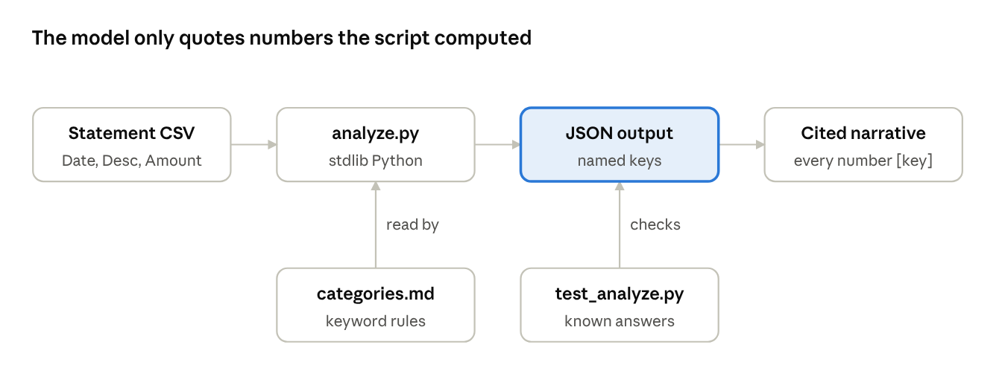
data flow · script computes, model narrates
The statement goes only through analyze.py; the model reads the JSON and writes the explanation, citing the key behind each number. test_analyze.py checks the script against known answers before the skill ever runs.

What analyze.py computes
Each output is a named JSON key, so the narrative can cite it. Thresholds are defaults the user can change with command-line flags.
Output | JSON key | Method
Monthly cash flow | monthly.<YYYY-MM>.income / spend / net | Sum positive and negative amounts per calendar month
Spend by category | categories.<name>.total / count | First matching keyword rule in categories.md; no match goes to uncategorized
Recurring charges | recurring[i] | Same normalized merchant, amount within 5%, at least 3 charges about 30 days apart (± 5 days)
Unusual charges | anomalies[i] | Amount above category median + 3 × MAD (median absolute deviation), so one big outlier cannot hide others
Possible duplicates | duplicates[i] | Same merchant and amount within 2 days
Data quality | meta.rows / skipped / date_range | Rows parsed, rows skipped with reason, first and last date
Merchant names are normalized first (uppercase, store numbers and card suffixes removed), so NETFLIX.COM 1234 and Netflix.com count as one merchant.

Why it exists
LLMs read statements well but add them up badly: totals over hundreds of rows drift, and a confident wrong number is worse than none. Moving every calculation into a tested script removes that failure mode entirely.
 | Skill 1 (jd-resume-tailor) | Skill 2 (this one)
Pattern | Instructions + reference files | Instructions + a script the agent runs
Trust mechanism | Source tag on every fact | Source key on every number
Code | None | Tested Python, standard library only
Evaluation | Trigger and quality runs | Unit tests with known answers, plus trigger and quality runs
The portability lesson: no pip install means the same skill runs in Claude.ai's sandbox, Claude Code, Codex and Gemini without setup.

Novelty
Spending summaries are not new; budgeting apps and chat assistants already produce them. The novelty is a contract: the model may only quote numbers the script produced, and must show where each came from.
Idea | What is different | Why it matters
Numbers from code only | The LLM never adds, averages or rounds; it quotes JSON values | Removes arithmetic hallucination, the main failure of AI money summaries
Source key on every figure | Each number carries its JSON key, e.g. [categories.dining.total] | Any claim can be checked in seconds; mirrors skill 1's source tags
Robust anomaly rule | Median + 3 × MAD per category instead of mean + standard deviation | One large purchase does not mask other unusual charges
Local and dependency-free | Standard-library Python, no APIs, no account linking | Statements never leave the machine; runs in any skill-capable agent
Editable rules | Categories and thresholds live in plain markdown and flags | Users tune it without touching code
The honest pitch: "a spending analysis where every number is computed, tested and traceable", not "the first AI budgeting tool".

Build plan
Six steps, each ending in a file you can run or check. Steps 1 to 3 build and prove the script before any instructions are written.
- Synthetic sample statement. sample-statement.csv: 3 months, about 150 rows, with planted answers (4 subscriptions, 2 unusual charges, 1 duplicate, 1 refund). Lesson: test data that encodes the expected result.
- analyze.py. Parse, normalize merchants, categorize, aggregate, detect recurring, anomalies and duplicates; print JSON. Lesson: deterministic tooling with a stable output contract.
- test_analyze.py. Runs the script on the sample and asserts every planted answer and every total. Lesson: the script proves itself before the agent trusts it.
- SKILL.md and references. Procedure: find the CSV, check columns, run the script, narrate using only JSON values with keys; plus categories.md and column-mapping.md. Lesson: instructions that call code and forbid mental math.
- Trigger and quality tests. 10 trigger prompts (5 should load, 5 should not) and a checklist: every number matches the JSON and carries a key. Lesson: the same eval method as skill 1.
- Package and publish. Plugin manifest, README, SECURITY.md, CI running test_analyze.py, install into all agents, directory submission. Lesson: reuse skill 1's release pipeline.

Setup, testing and publishing
The release pipeline is copied from jd-resume-tailor, so only the skill folder and the tests are new work.
Repo setup (new public repo txn-statement-analyzer, same layout as skill 1):
cd ~/Downloads/"AGENT SKILLS"
mkdir -p txn-statement-analyzer/{.claude-plugin,.github/workflows,evals,skills/txn-statement-analyzer/{scripts,references,examples}}
cd txn-statement-analyzer && git init -b main
python3 --version # 3.9 or newer; no packages to install
Testing, three layers:
Layer | Command or method | Pass when
Script | python3 scripts/test_analyze.py | Every planted answer and total matches
Trigger | 10 prompts in fresh chats, no slash command | 5 load, 5 do not
Quality | Run on the sample and one real statement | Every number equals a JSON value and carries its key
CI (GitHub Actions on every push): claude plugin validate ., python3 skills/txn-statement-analyzer/scripts/test_analyze.py, a check that no *.csv other than the sample is committed, and the 5-agent install check.
Publishing: plugin.json with icon, privacy, support and documentation links; README with Privacy, Troubleshooting and a sample-data walkthrough; SECURITY.md; install.sh reused from skill 1 with the skill name changed; then the claude.ai directory submission.
Privacy rule: real statements never go in the repo. .gitignore excludes *.csv except examples/sample-statement.csv.

Scope, risks and open decisions
Out of scope for v1: PDF statements, multiple accounts merged, currency conversion, budgets and forecasts, charts, and any bank or Plaid connection.
Risks:
- Bank CSV layouts vary (separate debit and credit columns, positive spend) → column-mapping.md plus a --debit-col/--credit-col option.
- Keyword categories miss merchants → report the uncategorized share and its top merchants so the user can add rules.
- The agent paraphrases or rounds numbers → hard rule to quote JSON values exactly, checked in the quality test.
- Real statements leak into git → .gitignore plus a CI check for stray CSVs.
- Directory policy on financial data → the skill only reads a file the user supplies and moves no money, so it stays outside the policy's unsupported financial-transaction category.
Open decisions:
- ☐ CSV format for v1: generic Date, Description, Amount (default) or your bank's export
- ☐ Repo: a separate txn-statement-analyzer repo (default) or one shared marketplace repo for all skills
- ☐ Python floor: 3.9 or newer (default)

